Qualitative Analysis of 11 Unknowns Student Laboratory Kit

**Introduction**

Identify 11l unknown substances by following a qualitative analysis flow chart. Learn to use a variety of chemical and physical tests to identify 11 common household substances, all of which are white solids. Concepts Qualitative analysis Physical and chemical properties. Flow diagrams Background The processor determining the identities of unknown substances is called qualitative analysis. This can be contrasted to quantitative analysis, which is the process of determining how much of a given component is presenting a sample. A qualitative analysis scheme using simple chemical and physical tests is designed, in this laboratory experiment, for the identification of 11 common household white solids: boric acid, calcium carbonate, calcium sulfate, cornstarch, levulose, magnesium sulfate, sodium bicarbonate, sodium carbonate, sodium chloride, sodium hydroxide, and sucrose. Qualitative analysis schemes are generally summarized by a flow diagram, like the one shown on page four. A flow diagram is designed with the procedural steps on the vertical lines, the possible test results on the horizontal lines, and the resulting identifications in the boxes.

Qualitative analysis procedures include physical tests as well as chemical tests. The physical tests in this 1ab are melting point determination and solubility in water or in alcohol. The chemical reactions or tests in this lab are with iodine, vinegar, sodium hydroxide, phenolphthalein, and Benedict's solution. All of these tests involve either formation of a precipitate, a color change, or evolution of gas bubbles. On the basis of observations, each of the eleven white household substances can be positively identified.

Experiment Overview The goal of this lab is to learn to use physical and chemical tests to determine the identities of unknowns A-K. Pre-Lab Notes The steps of the procedure correspond to the qualitative analysis flow chart provided on page 4. As each step is followed, record detailed observations of your results on the data sheet provided. . Examine the flow chart on page 4. The numbers 1-20 are provided next to each of the possible results. Write the corresponding number onto your data sheet as you go through the flow chart. For example, if unknowns A, B, and C art water-insoluble (which is result #1) and unknowns D-K are water-soluble (which is result #2), then write a "1" by A, B and C and record "Tn soluble in H_O"; and write a "2" by D-K and record" Soluble in H,O" on your data sheet. To further explain, if unknown "X" is found to be 1, 4, and 6, then the observations would read "n soluble in HLO, orange-brow NR) with L; NR with vinegar" on your data sheet. Following 1 to 4 to 6 on the flow chart, the unknown "X is the clearly identified as CaSO

Label11 test tubes A-K with a marking pen and place the tubes in a test tube rack.

2. Place a small scoop of each of the 11 unknown substances, A-K, into the appropriate test tube. (Note: A small scoop is the pea-sized amount that will fit on the end of a spatula, approximately 0.25 g. Results may be affected by using more than that amount.)

3. Add approximately 5 mL of distilled or deionized water to each tube. (Note: This can be efficiently accomplished by measuring S mL once using a 10-mL graduated cylinder. Pour the 5 mL of water into test tube A and then add water to each of the 10 remaining tubes to the same height of the liquid in tube A.)

4. a Stir the contents of each tube gently with a separate wooden splint to attempt to dissolve the solids. Record observations of which substances are soluble, and which are insoluble in water. Remember to record both the result#(1 or 2 as well as the written observation. (Note: Some soluble solids may take longer to dissolve than others.) Only three of the unknowns-cornstarch, calcium sulfate, and calcium carbonate-will not readily dissolve in water and are considered insoluble. I

5. Following the flow chart, take the three tubes from step 4 containing the insoluble substances. Add 2 drops of iodine zinc ture to each of the three tubes. Two of the tubes will show no reaction with iodine and will be an orange-brown color. The contents of one of the tubes will turn a deep blue color. The ep blue color is a starch-iodine complex which positively indicates cornstarch.

6. a Dispose of the contents of the two tubes that did not react with iodine. Rinse out the tubes. Prepare fresh tubes of these two unknowns by placing a small pea-sized scoop of the solid into the appropriate tube. Do not add water. b. Add approximately 10drops of vinegar to these two tubes and note whether gas bubbles are produced. The evolution of carbon dioxide gas positively identifies calcium carbonate. The remaining solid must be calcium sulfate. Record observations.

7.The other eight solids are water soluble. To each of the eight tubes from step 4, add 3-4 drops of phenolphthalein solution. Two of the unknowns, sodium hydroxide and sodium carbonate, dissolve in water to produce alkaline solutions basic enough to give a bright pink color upon addition of phenolphthalein. Do not be concerned with precipitate formation at this point, or with faint pink coloration.

8. a. Dispose of the contents of the two tubes that gave a positive test in step 7. Rinseout the tubes. Prepare fresh tubes of these two unknowns by placing a small scoop into the appropriate tube. Do not add water. b. Add approximately 10 drops of vinegar to each tube and note whether gas bubbles are produced. The evolution of carbon dioxide gas positively identifies sodium carbonate. The remaining solid must be sodium hydroxide.

9. a. Dispose of the contents of the tubes containing the six solids that remain to be identified. Rinse out the tubes. Prepare fresh tubes of these six unknowns by placing a small scoop into the appropriate tub. b. Add 5 mL of distilled or deionized water to the six tubes and gently stir as in step 4 to dissolve the solids.

10. Add 3 drops of 0.2 M NaOH to each tube. All of the tubes should remain clear except one tube which gives a white precipitate. This white precipitate positively identifies magnesium sulfate, which forms an insoluble hydroxide upon addition of sodium hydroxide.

11. a. Take the remaining five tubes from step 10 and add 10 drops of Benedict's qualitative solution to each tube.

b. Hold the tubes with a test tube holder and heat each tube gently over a Bunsen burner flame. Iin one tube, an orange precipitate will form while the remaining four tubes will stay blue in color. The color change to orange indicates that the copper ions in the Benedict's solution are being reduced to copper by a reducing sugar group. Levulose (fructose) is a reducing sugar, thus, this test is a positive identification for levulose.

12. a. Dispose of the contents of the tubes containing the four solids that remain to be identified. Rinse out the tubes. Prepare fresh tubes of these four unknowns. Do not add water.

b. Add approximately 10 drops of vinegar to each tube and note whether gas bubbles are produced The evolution of car bon dioxide gas positively identifies sodium bicarbonate.

13. a. Dispose of the contents of the three remaining tubes. Rinse out the tubes and prepare fresh tubes of these three unknowns. Do not add water.

b. Add approximately 5 mL . of isopropyl alcohol to each tube. Gently stir the contents of each tube to attempt to dissolve the solids. Of the three solids, only boric acid does not dissolve in alcohol; thus, this test is a positive identification for baric acid.

14. a Dispose of the contents of the two remaining tubes. Rinseout the tubes. Prepare fresh tubes of these two unknowns. Do not add water

b. Hold the tubes with a test tube holder and heat each tube gently over a Bunsen burner flame. The solid in one tube will turn brown, smell sweet, and begin to melt in 1-2 minutes. This is an indication that the material has a low melting point and that it is sucrose. The other solid will not change as it is heated. This indicates that the solid has a high melting point and is sodium chloride.

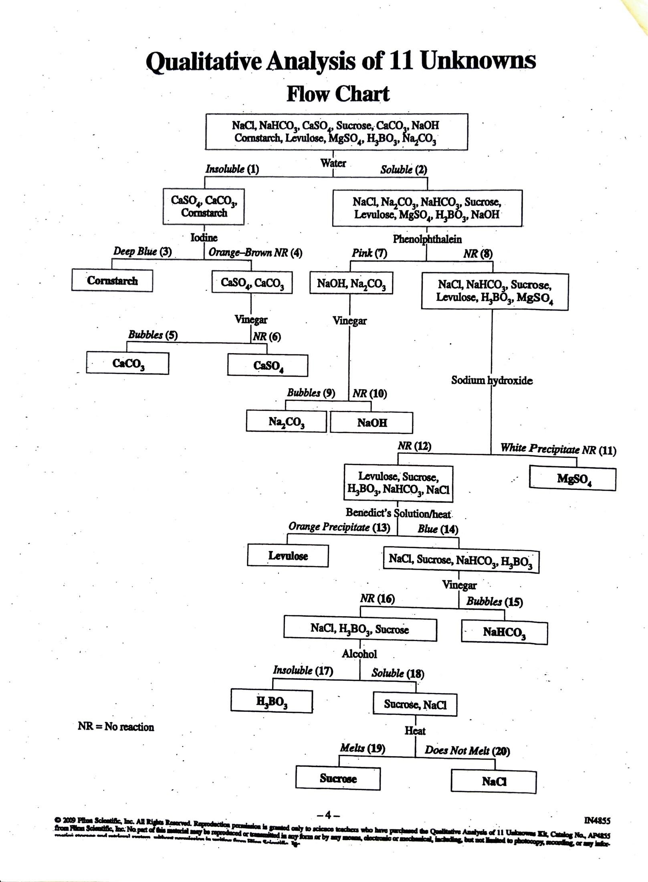

|  |  |  |
| --- | --- | --- |
| Unknown | Observations | Identity |
| A |  |  |
| B |  |  |
| C |  |  |
| D |  |  |
| E |  |  |
| F |  |  |
| G |  |  |
| H |  |  |
| I |  |  |
| J |  |  |
| K |  |  |